SOPHIA Consortium Meets in Brussels for 18-Month General Assembly and Stakeholder Event
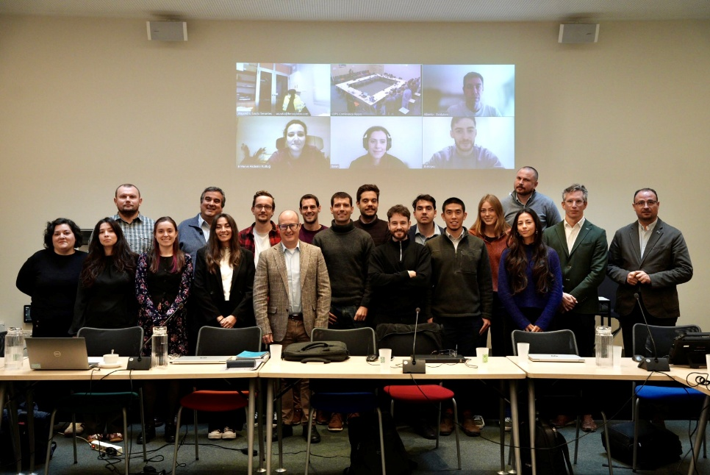
SOPHIA project partners at the third consortium meeting at CEPS, Brussels
Eighteen months into the SOPHIA project, partners gathered in Brussels, Belgium, for the third consortium meeting and the project's 18-month General Assembly, hosted by the Centre for European Policy Studies (CEPS) and organised by AIMPLAS, the project coordinator. Taking place on 3 and 4 November 2026, the meeting brought most partners together in person and gave the consortium the chance to look at how far the project has come and plan the next phase of work on making photovoltaic (PV) panels circular across Europe.
The agenda covered progress in every work package, from the collection and transport of end-of-life PV panels to the recovery of valuable materials. Partners also reviewed the project's mid-term deliverables, including the Policy Dossier, the training guidelines and the clustering report. A key item was the findings of the legislative review of the EU, Spanish and German frameworks, which drew on interviews with 24 stakeholders across the PV value chain. The consortium then agreed on next steps for the pilots, training activities and engagement with sister projects.
On the afternoon of 4 November, SOPHIA opened its doors to external stakeholders with a public event at CEPS. More than 50 participants, including policymakers, industry representatives and researchers, joined the discussion on the policy landscape for PV end-of-life management, followed by networking. As a growing share of Europe's installed solar capacity approaches end of life, the discussion showed how important it is to get both the technology and the policy framework right.
Looking ahead, SOPHIA enters its first reporting period at the end of November, with the next consortium meeting in six months. Launched on 1 June 2025, the project brings together 15 partners from across Europe, coordinated by AIMPLAS (ES): CIDETEC (ES), Fraunhofer (DE), WILOCK (ES), LHV (ES), SADAKO (ES), BIOSOLAR (NL), AKUMPT (BG), SISECAM (TR), FERROG (ES), IS (LT), Recyclia (ES), Recycling Europe (BE), CEPS (BE), ENCO (IT), working together to boost circularity across the entire PV panel value chain.
You can contact us at info@recyclingeurope.org. Don't miss a project update: sign up for the SOPHIA newsletter and follow us on X and LinkedIn!

