

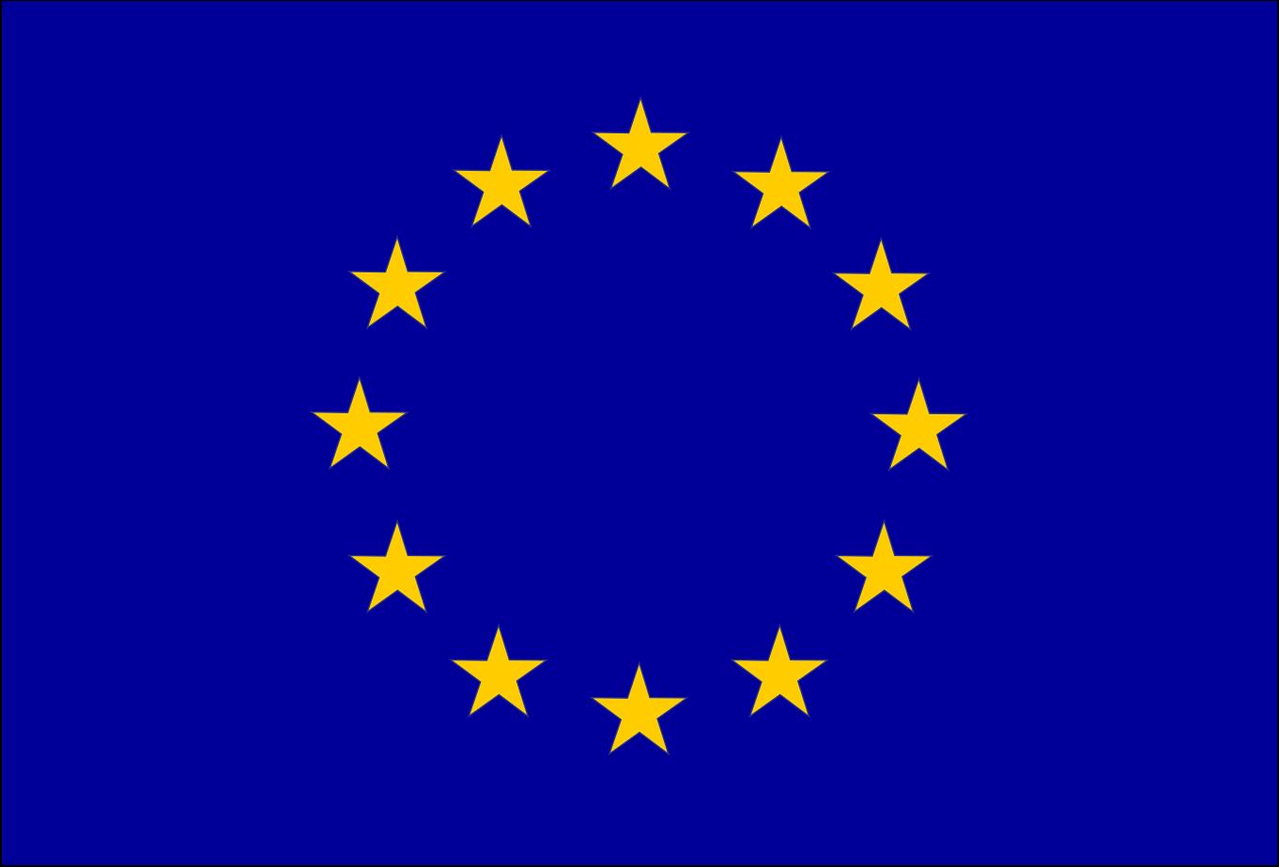
Funded by
the European Union

Closing the loop on solar: Recycling Europe and CEPS bring industry experts together to advance PV circularity

Brussels, 6 November 2026 – On 4 November, Recycling Europe and the Centre for European Policy Studies (CEPS) co-hosted the conference “Closing the loop on solar: circularity and digital traceability for PV panels” in Brussels, bringing together manufacturers, recyclers and industry experts to discuss the challenges and opportunities for a more circular European solar sector.

Organised in the framework of the EU-funded SOPHIA project, the event explored how digital product passports, improved traceability, ecodesign requirements and EU waste legislation can support a competitive and circular solar industry.

Opening the event, SOPHIA project coordinator Yasen Naydenov (Recycling Europe) and Maria Llàcer Llàcer (AIMPLAS) presented the project's objectives and progress. This was followed by a practical demonstration of a digital product passport by Miguel Díaz Escorihuela (WIBLO), illustrating how the technology could improve access to product information and traceability throughout the lifecycle of solar panels. Ioannis Tsanakas (SOLARIS project) also presented the work of this related EU-funded initiative, highlighting complementary efforts to advance innovation and sustainability in the solar sector.

During the panel discussion, moderated by Patricia Urban (CEPS), Ignacio Garcia (La Hormiga Verde) highlighted the regulatory challenges recyclers face when bringing recovered materials to market. In particular, complex end-of-waste procedures can create barriers even when customers for recycled materials have already been identified, as illustrated by the challenges surrounding glass recovered from solar panels. Pia Alina Lange (Trinasolar) addressed the limitations of solar panel reuse, noting that many returned panels have defects that reduce their suitability for second-hand markets. She also stressed the importance of the Ecodesign framework and the ongoing review of the WEEE Directive, particularly the need to better align collection targets with actual market developments. Mona Hassel (Biosphere Solar) highlighted emerging consumer interest in reused solar panels, while discussions on digital product passports underscored their potential to improve traceability and facilitate more informed decisions throughout the product lifecycle.

The conference highlighted that closing the loop on solar requires technological innovation, harmonised end-of-waste criteria, effective ecodesign requirements, reliable product information and functioning markets for recovered materials are essential to strengthening Europe's solar value chain.

The event’s material and photos will be available here.

Note to editor: Recycling Europe (formerly EuRIC) is the voice of Europe’s recycling industry, including 83 national federations and companies across 24 EU & EFTA countries. From metals and paper to plastics, textiles, tyres, ships, construction & demolition waste, WEEE and ELVs, our members transform waste into resources—powering Europe’s circular economy, ensuring resource autonomy, and boosting competitiveness and sustainable industrialisation across the continent. For press-related enquiries, please contact Zoi Didili, Recycling Europe’s Senior Public Affairs & Communications Advisor, by email at zdidili@recyclingeurope.org or by phone at +32 (0) 489 09 46.

